eBook

# The SUSE Guide to Edge Computing in a Cloud Native World

20S2USE.c2om

Introduction – Let’s define Edge

## Although the topological concept of edge computing may be decades old, the limitations imposed by the centralized implementation of hyperscale cloud and the growing investment in IoT have thrust edge topology into the limelight. Edge computing places content, data and

processing closer to the applications, things and users that consume and interact with them1.

Edge computing is entering the mainstream as organizations look to extend cloud to on-premises and to take advantage of IoT and transformational digital business applications1.

Depending upon where the edge infrastruc- ture is located, we can segment the Edge

landscape into three logical areas: Near, Far and Tiny.

Near Edge

Computing infrastructure that is between the data center and the far edge. For example, Cell tower-based compute, Telecom Central Offices, and Campus compute facilities.

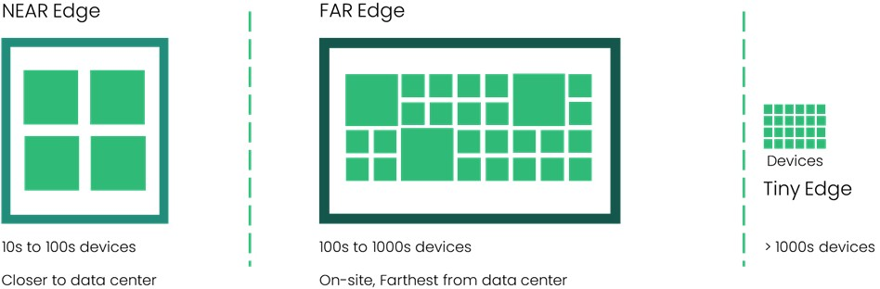

1 Gartner - 2022 Strategic Roadmap for Edge Computing

Far Edge

Edge computing infrastructure which is deployed in a location furthest from the data center. This will be on-site and close to the end-point devices (from a network latency perspective). Examples of Far Edge include:

* Commercial sector: Retail (shop or mall), Hospitality (hotel), Banking (local branch office), Education (school), Healthcare (medical center)
* Industrial sector: Agriculture, Oil and Gas (drilling location), Manufacturing (factory floor), Transportation (airline, trains), Energy (wind turbines), Utilities (electricity, water facilities)
* Public Sector: Defense and Intelligence, Civilian agencies, State and Local

Tiny Edge

The end-point itself (e.g. microcontroller enabled sensors, actuators, fixed function devices, etc.). Often referred to as “edge devices” – the Internet of Things (IoT) fit here. The tiny edge is typically within the same network as a Far edge service.

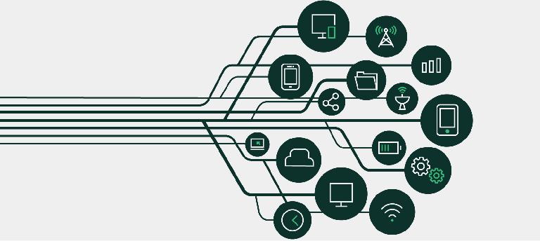

### Challenge: How to simplify lifecycle management of Edge devices

With edge devices, organizations achieve tremendous flexibility and modularity in designing the products/services that they can offer and do it at scale. On the flip side, the scale of deployment starts becoming a key element of design.

Organizations face some common pain points:

* Static builds of device firmware are no longer acceptable. Security patches and feature enhancements are routine and frequent.
* Device servicing/maintenance/updates must be delivered over the network as compared to onsite visit of a technician.
* Lifecycle management of these devices must be automated.

In order to address the pain points, the edge solution is expected to provide:

* Device registration and onboarding capabilities
* Leading security positioning

- Security is critical as edge deploy- ments lose the protection of the data center, introduce new attack vectors and lead to an increasing attack surface area.

* Deployment and management guidance

All the above needs to accommodate growth from 10s to 100s to 1000s and beyond. As the edge deployments scale, eliminat- ing or reducing the operational overhead of managing edge at scale becomes key. The challenge becomes one of “Management at Scale”. Combine that with the fact that market has yet to offer a fully-managed edge solution. So, to an administrator/ architect, the question becomes - Can we really have “Full Lifecycle Management” for the Edge?

### Our unique approach

SUSE’s approach is born in the cloud and meets the edge wherever it is – near, far or tiny.

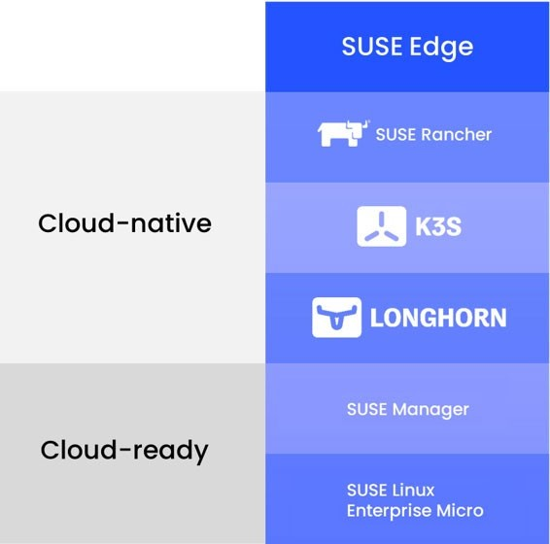SUSE is creating an open source, cloud native solution for full stack edge infra- structure management. A true open-source solution for full stack Edge infrastructure management, with following 3 foundations:

* Lightweight cloud-native edge stack, which is also Kubernetes-ready
* Reliable & secure edge infrastructure
* Aim for maintenance-free infrastructure

Lightweight Kubernetes at the Edge

SUSE Edge utilizes K3s - a CNCF sandbox project that delivers lightweight Kubernetes distribution fit for resource constrained and remote location or IoT devices.

K3s was built by the SUSE Rancher team and was donated to the CNCF in August 2020. K3s is production ready and packaged as a single binary optimized for ARM64 and ARMv7 support.

When used with SUSE Rancher, K3s provides users with an exceptionally reliable, comprehensive Kubernetes experience that confidently manages thousands of clusters across the Edge. Using SUSE Rancher’s GitOps-powered Continuous Delivery features, K3s users can manage up to 1 million edge clusters built on x86 or ARM64-based hardware with maximum consistency and efficiency.

Longhorn, also a CNCF project, is used to deliver a powerful, distributed, software- defined storage platform for Kubernetes that can run anywhere. When combined with SUSE Rancher, Longhorn makes the deployment of highly available persistent block storage for your edge-based Kubernetes clusters easy, fast, and reliable.

By supporting both x86 and ARM64 architectures, Longhorn is the first Kubernetes-native storage solution designed to help teams store data reliably within even the most remote, low-powered environments at the edge.

Operating System Built for Edge

100% open source and built using open standards, SLE Micro provides a reliable and secure OS Platform for the Edge. SLE Micro is built from ground up to support containers and microservices.

SLE Micro leverages the enterprise- hardened technology components of SUSE Linux Enterprise and merges that with what developers want from a modern, immutable OS platform to provide an ultra-reliable infrastructure platform that is also simple to use.

SLE common code base provides FIPS 140- 2, DISA SRG/STIG, integration with CIS and Common Criteria certified configurations. Fully supported security framework (SELinux) with policies is included.

Both Arm and x86 architectures are supported so you have architectural flexibility in deploying a broad range of edge applications.

Near Zero Maintenance

Our goal is zero maintenance - all routine maintenance functions like patches,

updates, config changes are performed seamless. When things go wrong, security signed and verified transactional updates are easy to rollback.

SUSE Rancher’s Continuous Delivery utilizes a ‘GitOps’ approach to help users manage and deploy thousands of Kubernetes clusters easily. Driven by project ‘Fleet’, Rancher Continuous Delivery gives users the ability to manage Kubernetes at the Edge across any infrastructure environment.

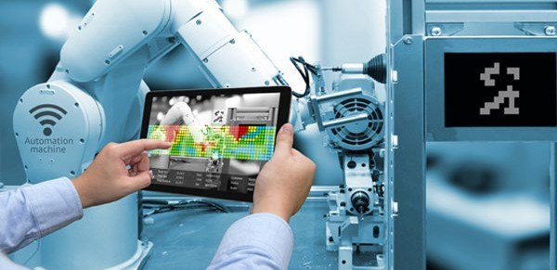In summary, the SUSE Edge solution addresses a broad set of use cases ranging from organizations that are cloud- ready to organizations ready for cloud- native. The solution is modular. So, when combined with SUSE Manager you can use it for edge use cases that are not fully containerized. For edge use cases that are fully containerized and cloud-native, Rancher can enable managing the lifecycle of large-scale edge setups down to the OS level2.

1. Check with SUSE team for availability of OS level manage- ment with Rancher.

### Industry Trends

Manufacturing

Prior to COVID-19, the global manufacturing industry had been re-building momentum and increasing productivity with heavy investments into technologies such as artificial intelligence (AI), enhanced connectivity, and Internet of Things (IoT). However, with the COVID-19 pandemic, the sudden forced shutdowns across the globe have forced many manufacturing organizations to reassess the acceleration of their digital transformation and find strategies to overcome the supply chain roadblocks and workforce restrictions instead.

As manufacturing trends regain momentum towards building connectivity and utilizing AI and IoT and applications, infrastructure decision makers and their teams will need to look at refitting their legacy solutions with cloud- native alternatives. Legacy systems have been a reliable solution for the industry over the last few decades however they are not conducive to creating the innovative agile development environment needed to transform.

Open-source tools and Kubernetes give development teams the opportunity to build high-performing resilient processes that can operate anywhere from on-prem, cloud and at the edge without being restricted by legacy solutions. Helping development teams establish an infrastructure strategy and environment that promotes flexibility, agility and resiliency across the business.

This gives decision makers an ideal environment to rapidly formulate new innovative strategies and explore new opportunities including robotics, automation and machine learning to help build a profitable and sustainable future for the industry whilst solving the current challenges around supply chain and resourcing.



Automotive

Having transformed the way we learn, communicate and work, the digital revolution is also redefining the way we commute. Due to technical maturity enabling more advancements possible, the automobile industry is poised to invest $52 billion in software focusing on autonomous driving and connectivity features by 2025. As a result, the autonomous driving software market is expected to increase at a compound annual growth rate of 17 percent between 2019 and 2025, and 30 percent of a car’s value will come from its software by 20303.

1. <https://www.suse.com/success/elektrobit/>

However, the automotive industry faces unique challenges:

* + Legacy automotive solutions, both at the infrastructure layer and application layer, lack the agility and flexibility required for rapid digital transformation.
  + Connected platforms should be hardware and cloud-agnostic, with no vendor lock-in and must employ open governance to support multiple clouds, on-premises, and edge use cases.
  + Automotive companies that can orchestrate containerized apps securely across any infrastructure, including the edge, will experience significant savings.

To remain competitive, players are using lightweight, embedded Linux operating systems and Kubernetes to build integrated cloud to edge platforms that deliver connected car use cases and explore new business models.

In the near term, automotive companies are exploring software over-the-air (SOTA) and firmware over-the-air (FOTA) updates.

Longer-term opportunities exist in the transfer of content to and from vehicles including insurance tracking and on- demand entertainment content. To be successful, automotive companies must deploy open, reliable and the flexible application platforms to the vehicle edge and develop cloud-based products that can monetize them.

Telecommunications

Telecommunication organizations are rapidly transforming to adapt to new consumer behaviors. With content and data consumption forecasted to exponentially grow, from new workplace, entertainment and schooling expectations, the availability of 5G-enabled services and the connectivity of Telco’s becomes a priority for consumers. This rapid adoption of 5G-capable mobile and edge platforms creates a new wave of data as consumers expect more customized content on-demand.

As per the Analysys Mason survey4 of 30 Tier-1 operators from 12 countries - “Edge computing is of high strategic importance to operators, and first-movers are forging ahead with early deployments. 87% of the operators in survey consider edge computing to be a top strategic priority in the short term.” The survey also indicated that video and gaming are expected to be the common early use cases for edge.

1. Survey by research and consulting firm Analysys Mason.

The telecom industry faces the following challenges:

* + Kubernetes-based containers-as-a service (CaaS) will replace VM-based infrastructure-as-a-service (IaaS) such as OpenStack over the next decade.
  + Specialist providers still dominate the telecom’s market, offering integrated core services for EPC, IP Multimedia Subsystem (IPMS), Subscriber Data Management (SDM), etc. that force customers to select siloed solutions from just one vendor.
  + Telco leaders are concerned about the cost, lock-in, and lack of agility offered by legacy solutions.

T o me e t n e w co n s u me r de man ds and remain competitive, Telco’s must orchestrate and containerize workloads across their network and replace legacy infrastructure solutions with new cloud- native alternatives. In order to manage their geographically dispersed network locations and deliver 5G-services, Telco’s must leverage cost effective, open-source solutions such as Kubernetes. These cloud native solutions will become a necessity to help Telco’s retain their market share from Over-The-Top providers and help build the efficiency and flexibility needed to transform.

Upskilling engineering and development teams to deploy scalable cloud-native infrastructure solutions will be fundamental

in a telco’s ability to succeed in managing the volume of expected data. As operational strategies focus to consumer retention and satisfaction, data captured will be used to help create competitive advantage. This is where open-source solutions will play a pivotal role in capitalizing these trends as telco’s look to simplify, modernize, and accelerate their service delivery.

Healthcare

Technology has had an immense impact on how the healthcare industry operates. Patients and medical practitioners now rely on technology including artificial intelligence, machines and big data to make better health decisions.

New patient services like telehealth are expanding the reach of medical practitioners but are also placing new pressures on IT operators to deliver secure and reliable network and connections for off-site and video consultations often across multiple devices and locations.

The digitization of patient records and diagnostic data transmission also presents another challenge for IT operations who need to fortify their infrastructure stack against the increasing number of cyber and ransomware attacks targeting the aging Windows-based environments common across the healthcare sector.

Tackling the newness of these technologies and growing threats also presents

another challenge. Commonly publicly funded, healthcare technology teams face limitations around budgeting and resourcing to attract the necessary talent required to implement and sustain these solutions. Combined with the scarcity of technology talent, the high recruitment cost for IT operators is often a prohibitive factor of healthcare providers to modernize their technology stack and environment.

Cloud-native solutions provide the healthcare sector reliable, scalable and resourceful alternatives to improve their legacy infrastructure solutions. Often lightweight and compatible with edge environments these solutions give technology teams in healthcare an accessible ecosystem of tools that can be retrofitted into their existing complex legacy stacks.

Solutions like SUSE Edge enable healthcare providers to build the developer agility needed to help them digitally transform. By utilizing a suite of open-source, lean, enterprise grade products including Linux, Kubernetes and SUSE Rancher – IT operators can attract talent, manage their environment and modernize their stack without compromising on security, performance and resource budget.

### Success Stories

Aerospace Company

Providing highly advanced, high-resolution

images and delivering them back to earth in real-time means a substantial bandwidth overhead. The aerospace company has focused on reducing bandwidth by building processing capabilities into local ground stations to address this challenge.

Running on Kubernetes, the distributed infrastructure platform provides a consistent framework for application development while allowing teams to configure and secure deployments for different use cases rapidly.

Using SUSE Rancher, Kubernetes clusters within ground stations can scale up and down at a moment’s notice to perform heavy- duty image analysis. The data is processed locally, then packaged and delivered with far less bandwidth requirements, more efficiently, and at a much lower cost.

The aerospace company’s Kubernetes strategy has had a marked impact. By using a common methodology, development projects are completed faster and more consistently using defined rules. Their cloud native infrastructure platform is accessible 24 hours a day, seven days a week, with access tightly controlled by Rancher. By adding technologies like K3s, the company envisions future data processing taking place on the satellites themselves, at the point of image capture.

Continental

Founded in 1871, Continental offers safe, efficient, intelligent, and affordable solutions for vehicles, machines, traffic, and transportation. The company is now present in 59 countries and has more than 232,000 employees around the globe.

When containers emerged, Continental’s IT operations team saw an opportunity to streamline infrastructure management. The primary driver for adopting a cloud native, container-centric strategy was to transform Continental’s manufacturing infrastructure into an agile, cloud native, and platform- based architecture. Adopting Kubernetes and Rancher has had a marked impact on

the company’s operations.

Managing this Kubernetes-based infrastructure platform in Rancher,

Continental has created a highly agile and scalable application framework, which has removed complexity and significantly reduced management overheads. Their new containerized architecture allows them to run applications in separate clusters in any geographic location, with development, test, and production environments already in place. If they need a place to spin up new containers to try new ideas, they can create them in minutes.

In 2022, the Continental team will extend their Kubernetes rollout to 45 locations globally, covering more than 1,000 different services in

“Transforming large manufacturing organizations like Continental is a huge technical and philosophical challenge. The emphasis is on finding the most intuitive and efficient way to modernize while maintaining competitive advantage. Kubernetes and Rancher will help us achieve this.”

Roland Paxián, Manufacturing Infrastructure Team Lead, Continental

50,000 production stations. Once complete, they plan to use Rancher’s Continuous Delivery capabilities to manage custom apps on up to 400,000 edge devices running K3s.

Elektrobit

Elektrobit is a global supplier of embedded and connected software products and

services for the automotive industry. A leader in automotive software with more than 30 years serving the industry, Elektrobit’s software powers over one billion devices in more than 100 million vehicles and offers flexible, innovative solutions for car infrastructure software, connectivity and security, automated driving, and user experience.

Due to visionary companies like Elektrobit, autonomous driving and the connected car are no longer future ideas but realities on the road today. As the speed of innovation



increases across the automotive industry, vehicles are now as much software platforms as chassis and engines. This fundamental shift away from hardware dominated to software-defined vehicles means there is a need to completely rethink the customer experience of the future best-selling vehicles.

Software-defined vehicles bring new experiences to both manufacturers and drivers. No longer will car owners need to sit at the auto shop to replace outdated firmware. Maintenance and features will be delivered not through an appointment with a dealer but automatically over the

air. Autonomous driving means software- driven cars, and Linux will be at the heart of ensuring the performance, safety, and security of that software.

Elektrobit and SUSE aim to provide an open and transparent software platform for automobiles that includes seamless system updates over the air.

In the future, SUSE technology will power autonomous driving, and ultimately, deliver a technology platform that everyday consumers will depend on for their transportation needs. What is developed in conjunction with Elektrobit will lay the foundation for software deployed in other industries just as critical to our lives, such as aerospace, healthcare, and beyond.

Hypergiant

Hypergiant creates emerging AI-driven technologies for Fortune 500 and government clients in space science and exploration, satellite communications, aviation, defense, healthcare, transportation, and more.

[SUSE Rancher Government Solutions](https://susergs.com/)

“We’re proud to partner with SUSE to bring this vision to life. We have confidence that to- gether we will create cutting-edge solutions for the market that will transform how cars are powered, not a few years down the line, but in the next generation of automobiles.”

Alexander Kocher, President & Managing Director, Elektrobit

is partnering with Hypergiant and DOD PlatformONE to do the impossible – putting Kubernetes on satellites for the first time. Together, the team will demonstrate the benefits of DevSecOps, Kubernetes, and AI/ML apps in remote and often disconnected environments. Working with K3s, the Hypergiant team is developing and integrating their software pipeline with the EdgeONE and SatelliteONE missions,

including the launch of a K3s-embedded satellite planned in 2022.

The satellite industry faces several significant challenges. Firstly, software development and delivery on space-rated hardware are costly, slow, and cold. Very cold. On average, temperatures in space are 2.7 Kelvin (-455 Fahrenheit or -270 Celsius). Consequently, in-orbit satellite software updates are often not possible or incredibly time-consuming and expensive. As a result, AI/ML capabilities are far behind those currently available

on earth. Secondly, satellite connectivity and bandwidth are poor, which makes downloading large images and other data difficult.

The SatelliteONE mission was designed to solve these challenges. The project will demonstrate DevSecOps in space by leveraging PlatformONE’s CI/CD pipeline alongside K3s provisioning and deployment.

“K3s is helping us build confidence in modern systems. We need to demonstrate the ability to update mission-critical applications and components, recover from failure, rollback, and roll forward. We need to prove reliability and survivability in space and on the ground – this is the key to making Kubernetes successful at the edge.”

Bren Briggs, Director of DevOps and Cybersecurity, Hypergiant

Importantly, it will evaluate the use of lower- cost hardware on satellite payloads, show how the rapid delivery of software updates in space can be done, and demonstrate the use of AI/ML software in orbit.

### Looking Ahead

To dig deeper into emerging use cases for running Kubernetes and adaptable Linux at the edge, we welcome you to watch the sessions, case studies, demos and conversations with open source experts at SUSECON Digital 2022 <https://susecon.com/>.

We look forward to engaging with you. Feel free to reach out to SUSE Team @ [https://](https://www.suse.com/contact/) [www.suse.com/contact/](https://www.suse.com/contact/).

SUSE

Maxfeldstrasse 5

90409 Nuremberg [www.suse.com](http://www.suse.com/)

For more information, contact SUSE at:

+1 800 796 3700 (U.S./Canada)

+49 (0)911-740 53-0 (Worldwide)

Thank You

235-001160-001 | © 2022 SUSE LLC. All Rights Reserved. SUSE and the SUSE logo are registered trademarks of SUSE LLC in the United States and other countries. All third-party trademarks are the property of their respective owners.